# Exercises: HTML Forms and Styling Exercise and Homework

Problems for exercises and homework for the “HTML and CSS” course @ SoftUni. Submit your solutions in the SoftUni judge system at <https://judge.softuni.bg/Contests/410/HTML-Forms-and-Styling> .

## Search Job

Create a Web page (HTML5 + CSS3 + images) that looks and behaves like the screenshots below:

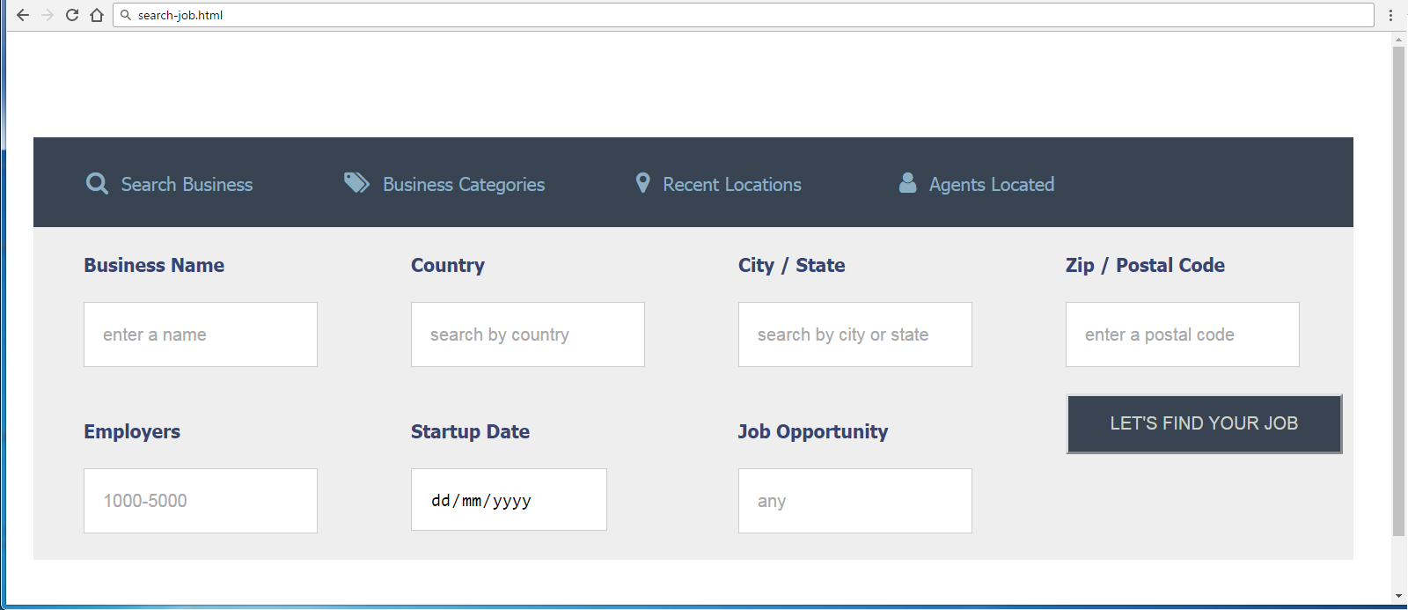

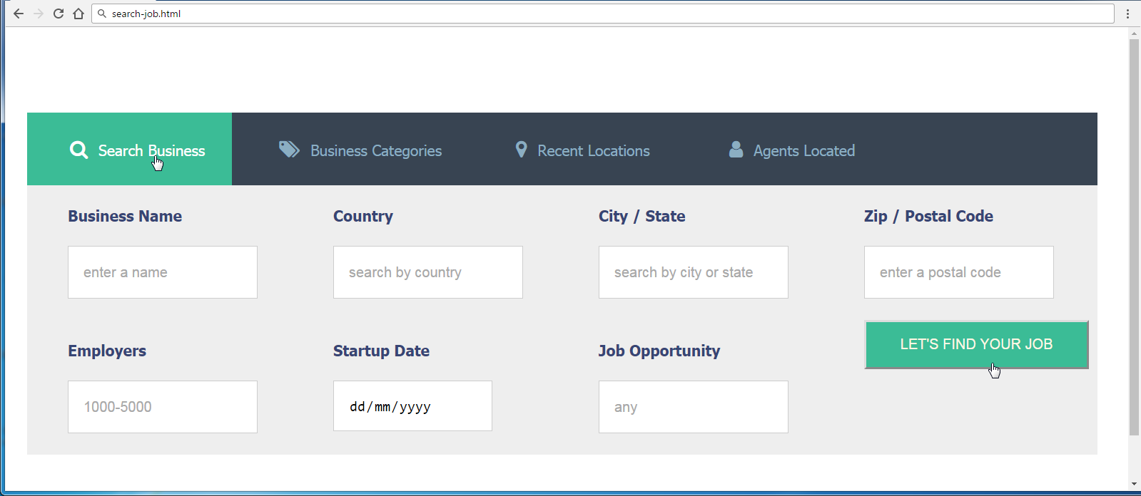

### Steps to Follow

Start with the **site header**:

* @import url('<https://cdnjs.cloudflare.com/ajax/libs/font-awesome/4.7.0/css/font-awesome.css>');
* <ul>, nav, label
  + Margin 0px
  + Padding 0px
* <body>
  + Text-size: 14px;
  + Font-Family: Tahoma, Helvetica, sans-serif;
  + Padding: 80px 50px;
* <nav>
  + Width: 70%;
* Style the unordered list <ul> in the site navigation
  + Background-Color: #384452;
* Style the list items <li> in the site navigation
  + Display: Inline Block
  + Remove the bullets
  + Padding: 25px;
* Style hyperlinks
  + Remove the bullets
  + Margin Left: 15px;
  + Text Color: #8BAEC2;
* <a> before
  + Font Family**:** FontAwesome, serif;
  + Margin Right: 10px;
  + Font Size: 18px;

Test the site navigation in the browser:

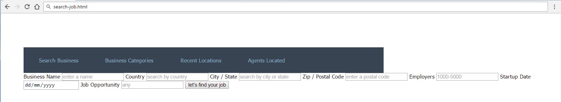

* li:first-child a::before
  + content: "\f002";
* li:nth-child(2) a::before
  + content: "\f02c";
* li:nth-child(3) a::before
  + content: "\f041";
* li:nth-child(4) a::before
  + content: '\f007';
* <li> hover
  + background-color: #3BBC96;
* <li> hover a
  + Text Color: #ffffff

Test the site navigation in the browser:

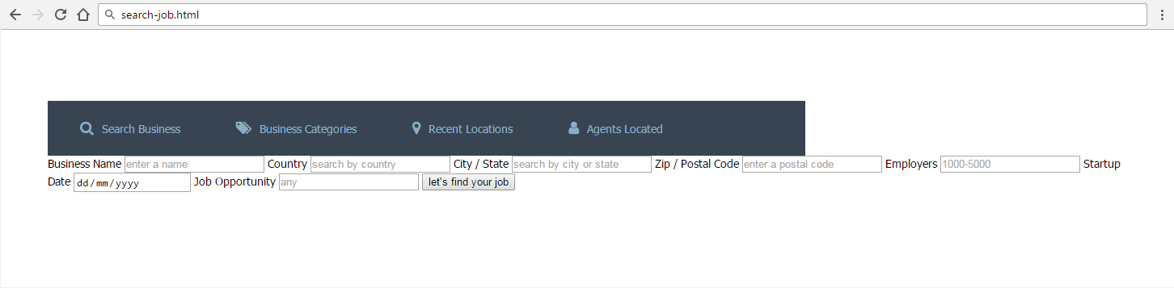

Style the Main content block:

* Make the background #EEEEEE
  + Use 70% width.
  + Display: Flex;
  + Flex-Wrap: Wrap;
* Label
  + Color: #374574;
  + Display: block;
  + Font Weight: bold;
  + Width: 210px;
  + Margin Left: 38px;
  + Margin Top: 20px;
* Input
  + Border: 1px solid #CDCDCD;
  + Margin Top: 20px;
  + Margin Bottom: 20px;
  + Height: 46px;
  + Padding Left: 14px;
* Button
  + Margin-left: 38px;
  + Width: 210px;
  + Height: 46px;
  + Text-transform: uppercase;
  + Background-color: #384452;
  + Color: #CED1CA;
* Button hover
  + Background-color: #3BBC96;
  + Color: #FFF7E4;
  + Cursor: pointer;

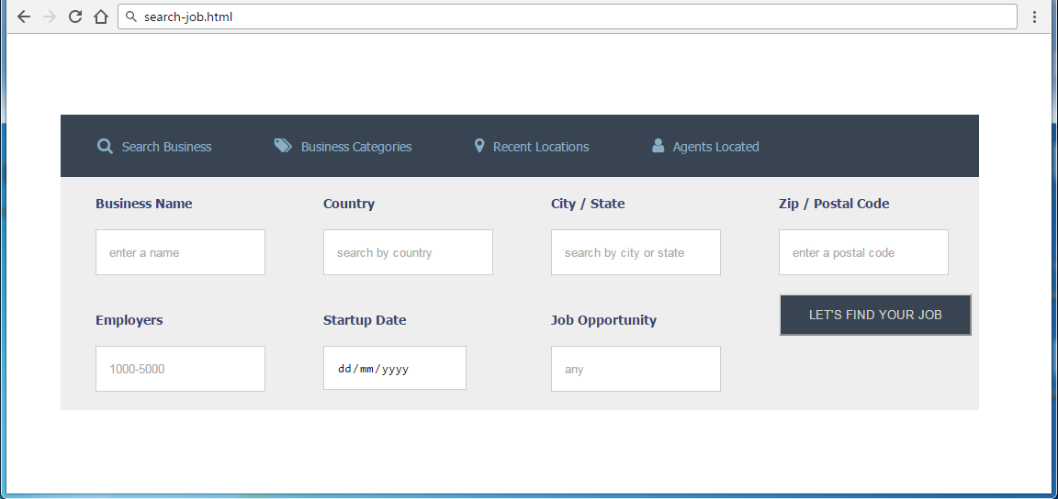

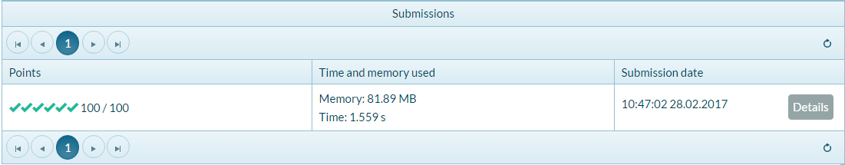

## Product Form

Create a Web page (HTML5 + CSS3 + images) that looks and behaves like the screenshots below:

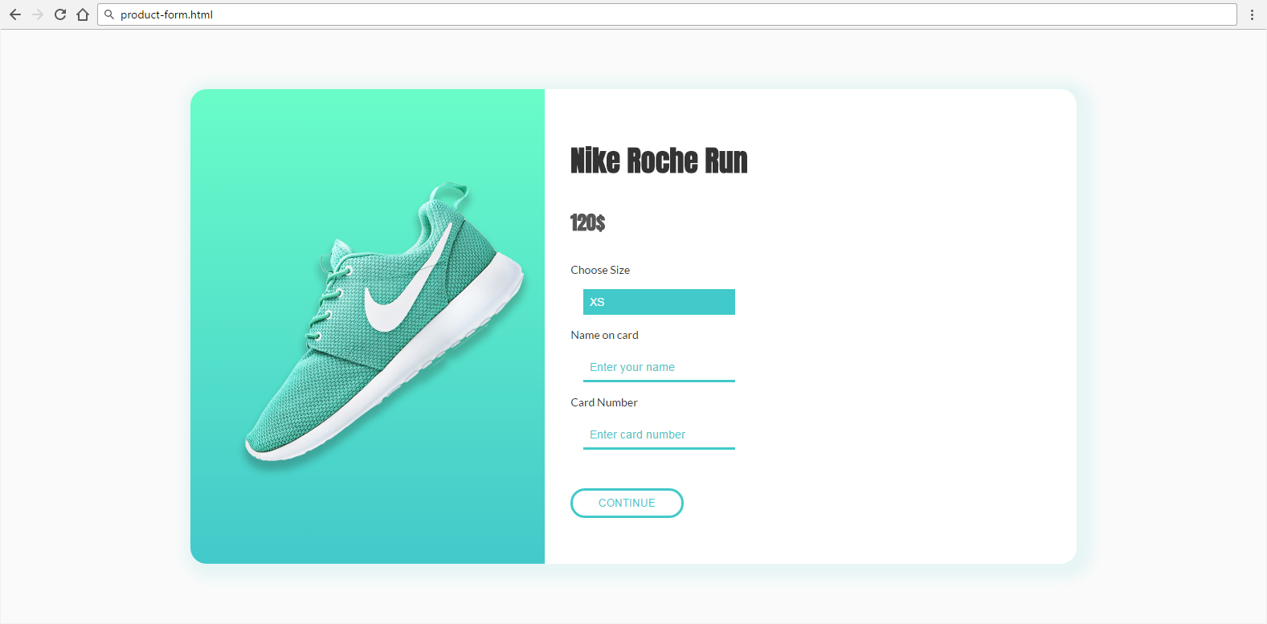

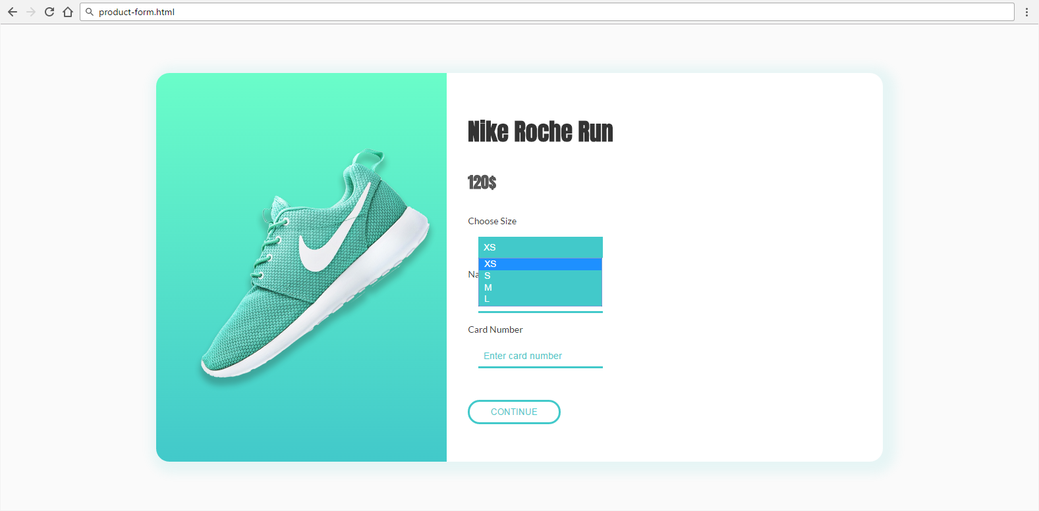

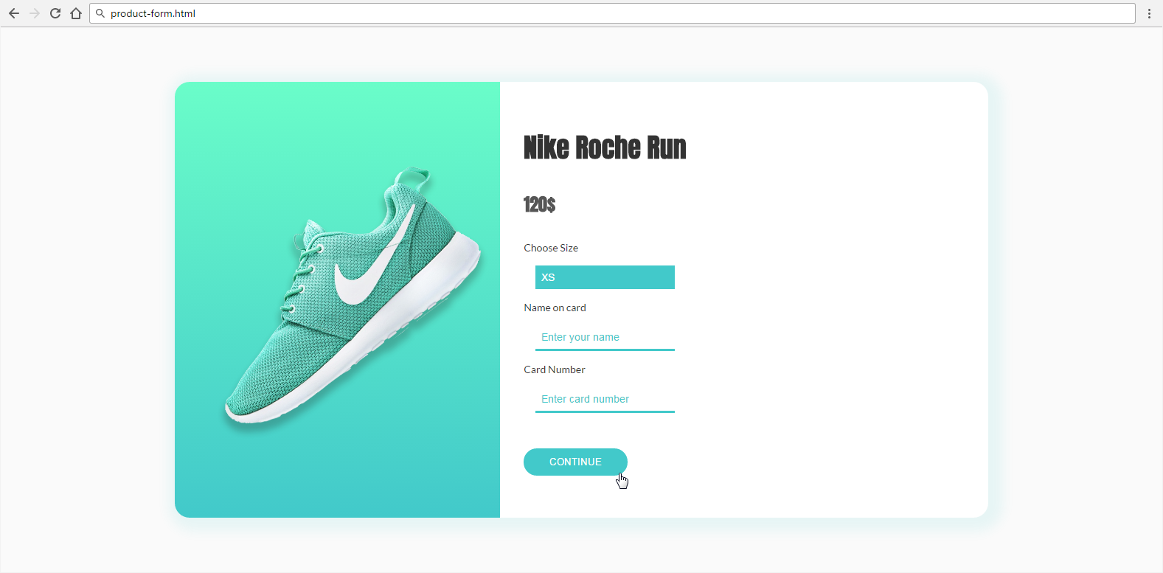

* The mouse cursors in the above screenshots explain what happens when the mouse moves over a project or a group and when the browser window resizes.

### Input

You are given the above screenshots + all required images + the texts on the site.

### Output

The output should be valid HTML5 + CSS3 + images that implement the above Web page.

### Constraints

* Font: 14px 'Lato', sans-serif.
  + <https://fonts.googleapis.com/css?family=Lato:400,700>
  + <https://fonts.googleapis.com/css?family=Anton>
* Background gradient: linear-gradient(to bottom, #6afdc9 0%,#42c9ca 100%)
* Form validation is not required.
* Responsive design is not required.
* Pixel-perfect implementation is not required.
* Take the colors from the pictures with color picker.

# * Exam Problems

**All of the problems below are given on Web Fundamentals (HTML & CSS) Practical Exams.**

**You are not obligated** to submit any of them in your homework. We highly recommend you to try solving some or all of them so you can be well prepared for the upcoming exam. If you still find those problems too hard for solving it’s very useful to **check** and **understand** the solutions.

## Room Reservation

Create a Web page (HTML5 + CSS3 + images) that looks and behaves like the screenshots below:

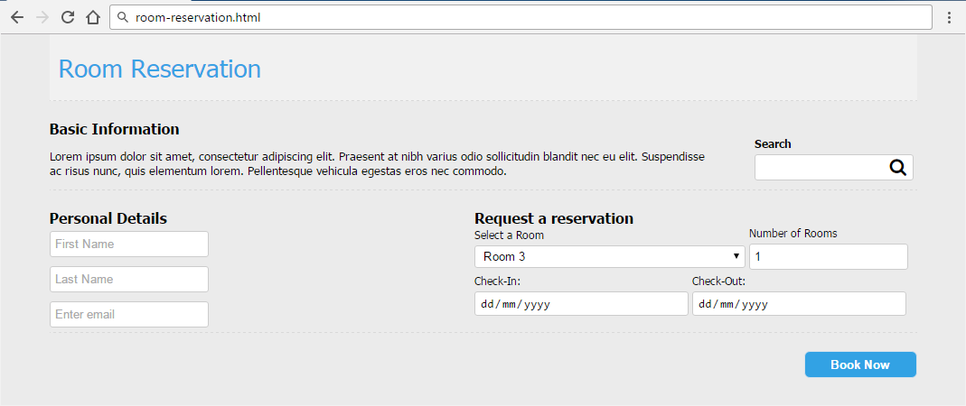

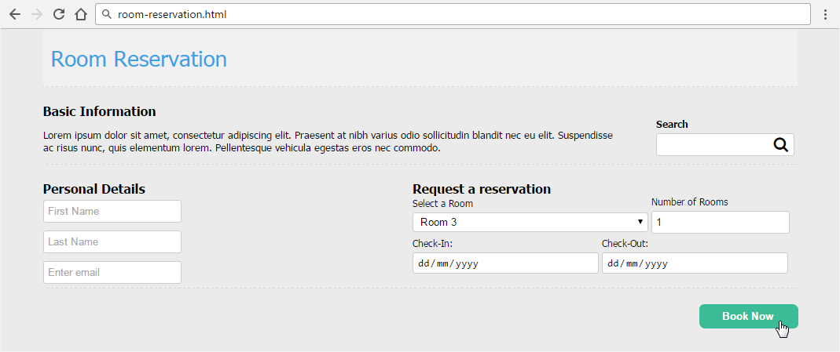

* The mouse cursors in the above screenshots explain what happens when the mouse moves over a project or a group and when the browser window resizes.

### Input

You are given the above screenshots + all required images + the texts on the site.

### Output

The output should be valid HTML5 + CSS3 + images that implement the above Web page.

### Constraints

* Font: 13px Tahoma, Helvetica, sans-serif.
* Title: 28px; Subtitle: 16px; Tahoma, Helvetica, sans-serif.
* “Select a room” is drop-down.
* “Number of rooms” is number field.
* “Check-in” and “Check-out” are date fields.
* Other fields are text.
* Form validation is not required.
* Responsive design is not required.
* Pixel-perfect implementation is not required.
* Take the colors from the pictures with color picker.

## Free Account

Create a Web page (HTML5 + CSS3 + images) that looks and behaves like the screenshots below:

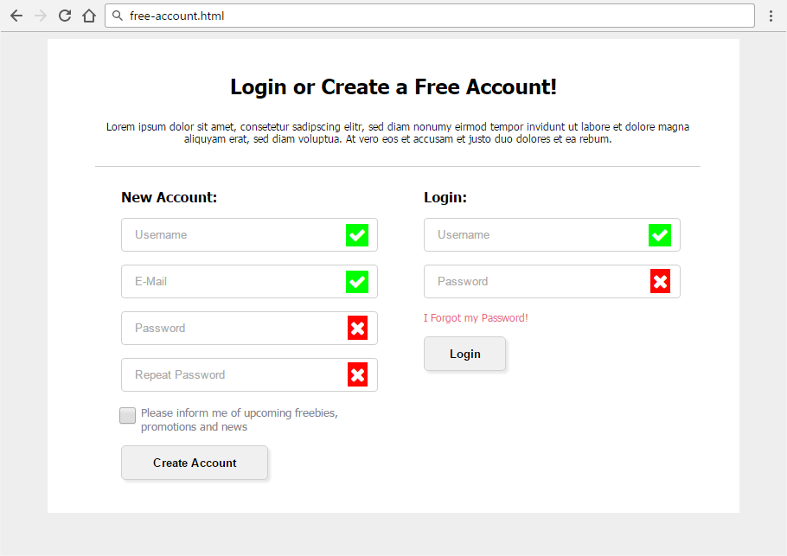

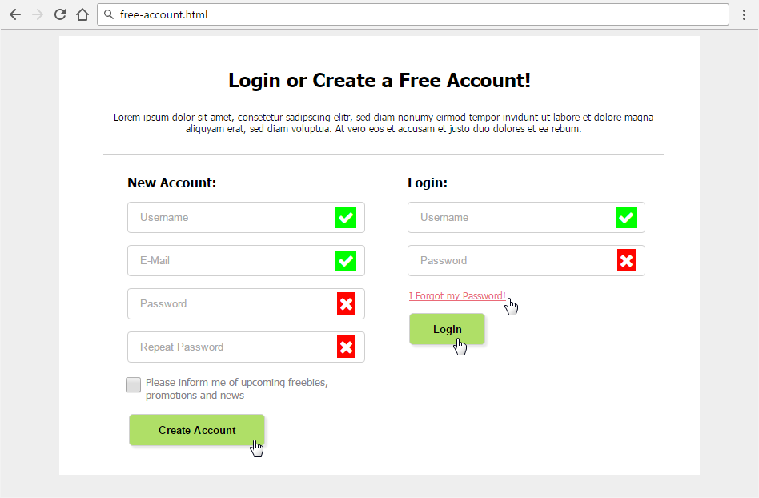

* The mouse hand-pointers and the bottom bar in the screenshots are not part of your page, so please skip them.

### Input

You are given the above screenshots and all required images.

### Output

The output should be valid HTML5 + CSS3 + images that implement the above Web form.

* You do not need to implement form validation.

### Constraints

* Font: Tahoma, Helvetica, sans-serif.
* Site content: fixed width 800px.
* Heading font-size: 24px.
* Form validation is not required.
* Responsive design is not required.
* Pixel-perfect implementation is not required.
* Icons: content: '\f00c'; content: '\f00d'**;**
* Take the colors from the pictures with color picker.

## Edit User Form

Create a Web page (HTML5 + CSS3 + images) that looks and behaves like the screenshots below:

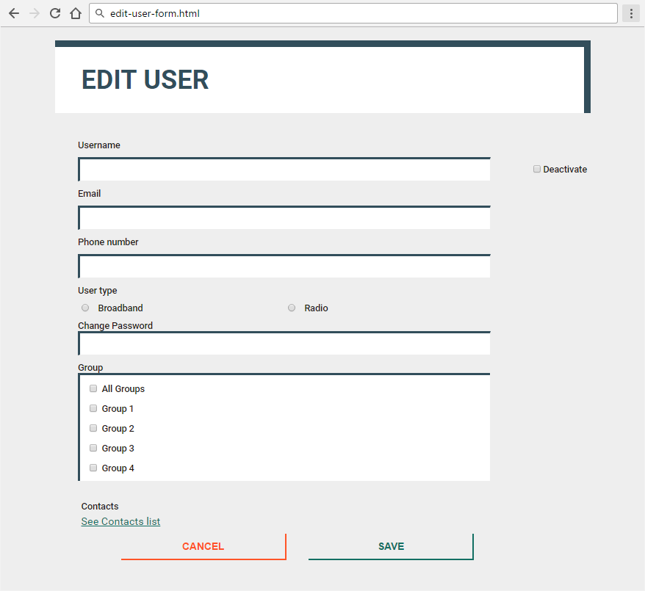

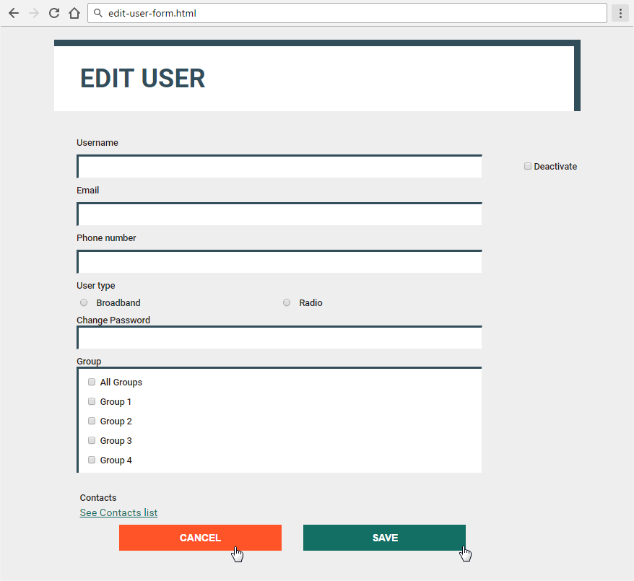

* The mouse hand-pointers and the bottom bar in the screenshots are not part of your page, so please skip them.

### Input

You are given the above screenshots + the images for the news items + the texts on the site.

### Output

The output should be valid HTML5 + CSS3 + images that implement the above Web page.

### Constraints

* Font: 16px "Roboto", Helvetica, sans-serif;
* <https://fonts.googleapis.com/css?family=Roboto:400,500,700>
* Default text: #1E1917;
* Title: 40px;
* Labels: 14px/500;
* Buttons font-size: 15px/700;
* Link: #136F63, 15px, no-hover effect
* Content max-width: 800px;
* Form validation is not required.
* Responsive design is not required.
* Pixel-perfect implementation is not required.

## Extreme Reservation

Create a Web page (HTML5 + CSS3 + images) that looks and behaves like the screenshots below:

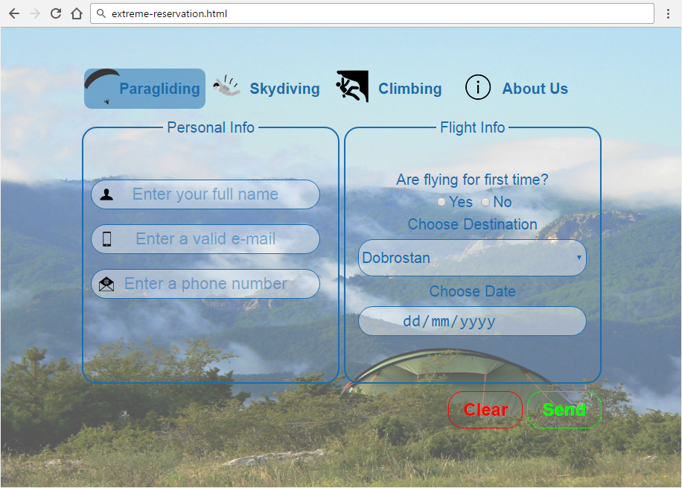

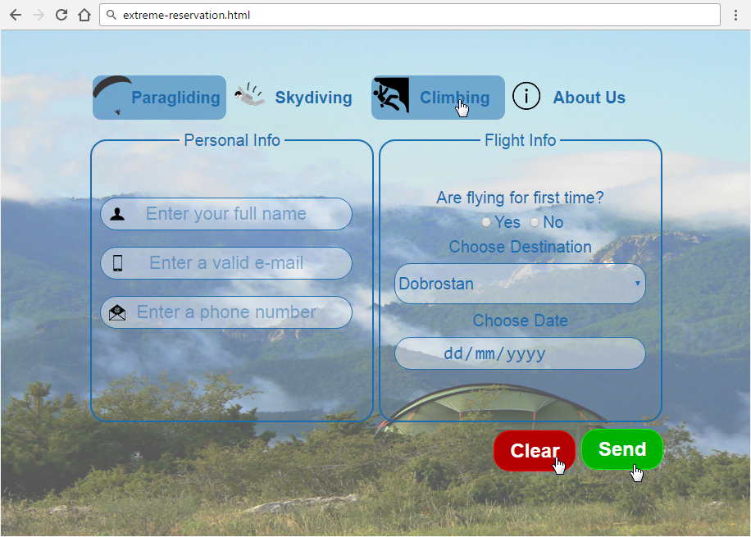

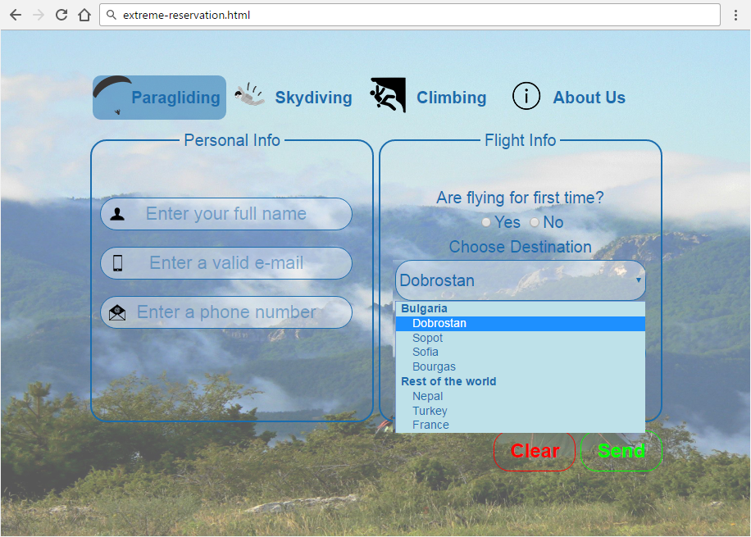

* The mouse hand-pointers and the bottom bar in the screenshots are not part of your page, so please skip them.

### Input

You are given the above screenshots + the images for the news items + the texts on the site.

### Output

The output should be valid HTML5 + CSS3 + images that implement the above Web page.

### Constraints

* Fonts: "Arial**"**, **"**Helvetica**"**, sans-serif; 20px
  + Input fields and Destination: 22px.
  + Destination options font-size: 14px.
  + “Send” and “Reset”: 24px.
* Site content: fixed width 800px.
* Form validation is not required.
* Responsive design is not required.
* Pixel-perfect implementation is not required.
* Take the colors from the pictures with color picker.